Module Name: STUDENT RECORDS MANAGEMENT
Test Case ID: TC_01
Test Scenario: Unit Test (Add New Student Details)
Test Objective: Verify Student Data Entry
Precondition: Application Opened
Test Environment: Java, Eclipse IDE
Expected Result: Student Result Display
Status (Pass/Fail): Pass
SCENARIO 1A: UNIT TEST - ADD NEW STUDENT DETAILS
Unit testing execution for verifying student entry logic and parameters.
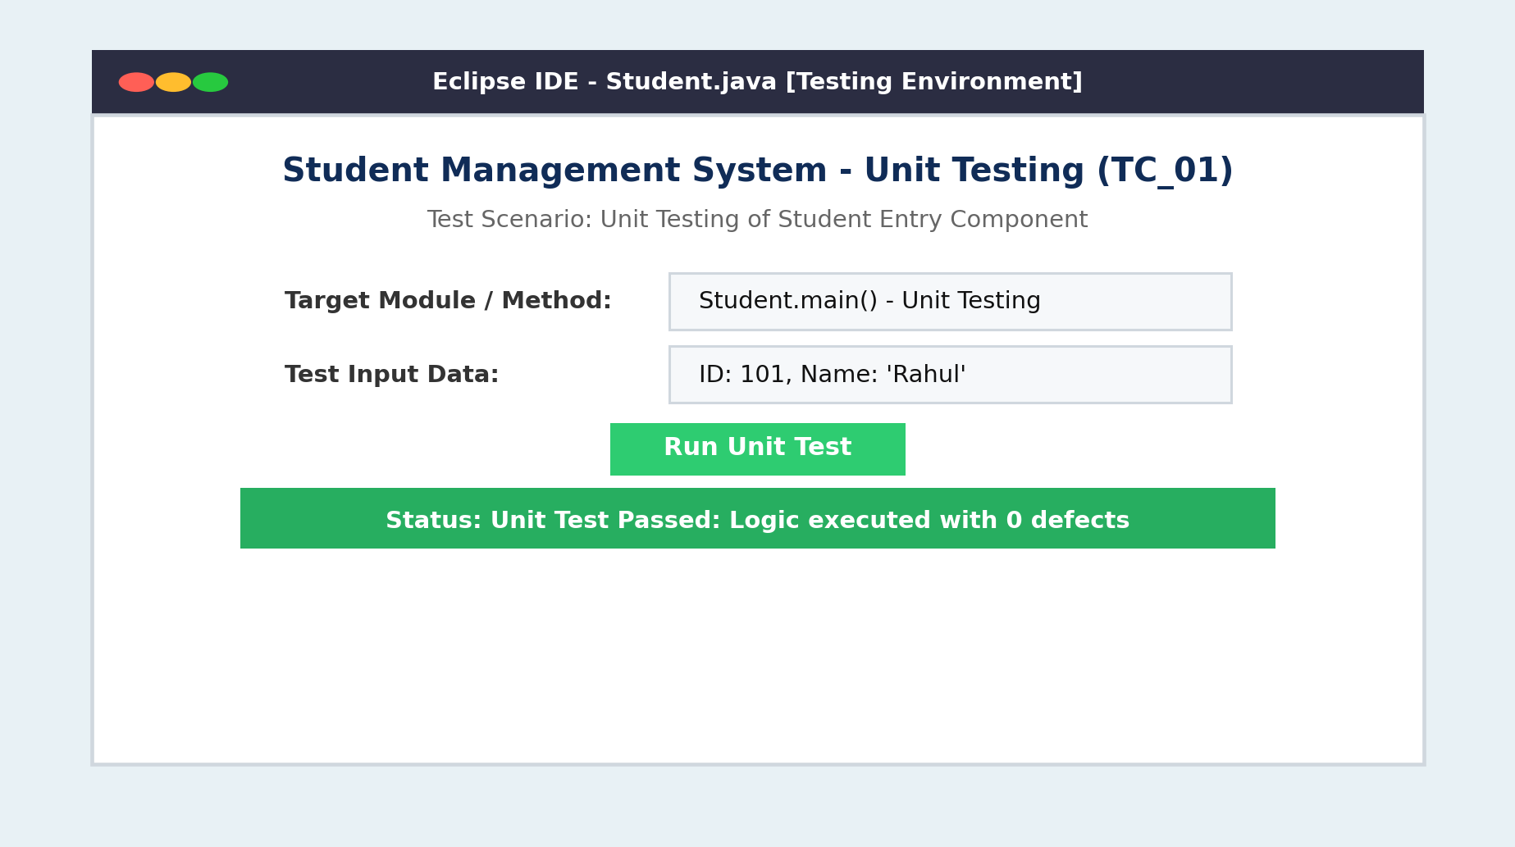
TEST OBJECTIVE: STUDENT VERIFICATION PAGE
Verification of student data entry (ID: 101, Name: Rahul) in the system.
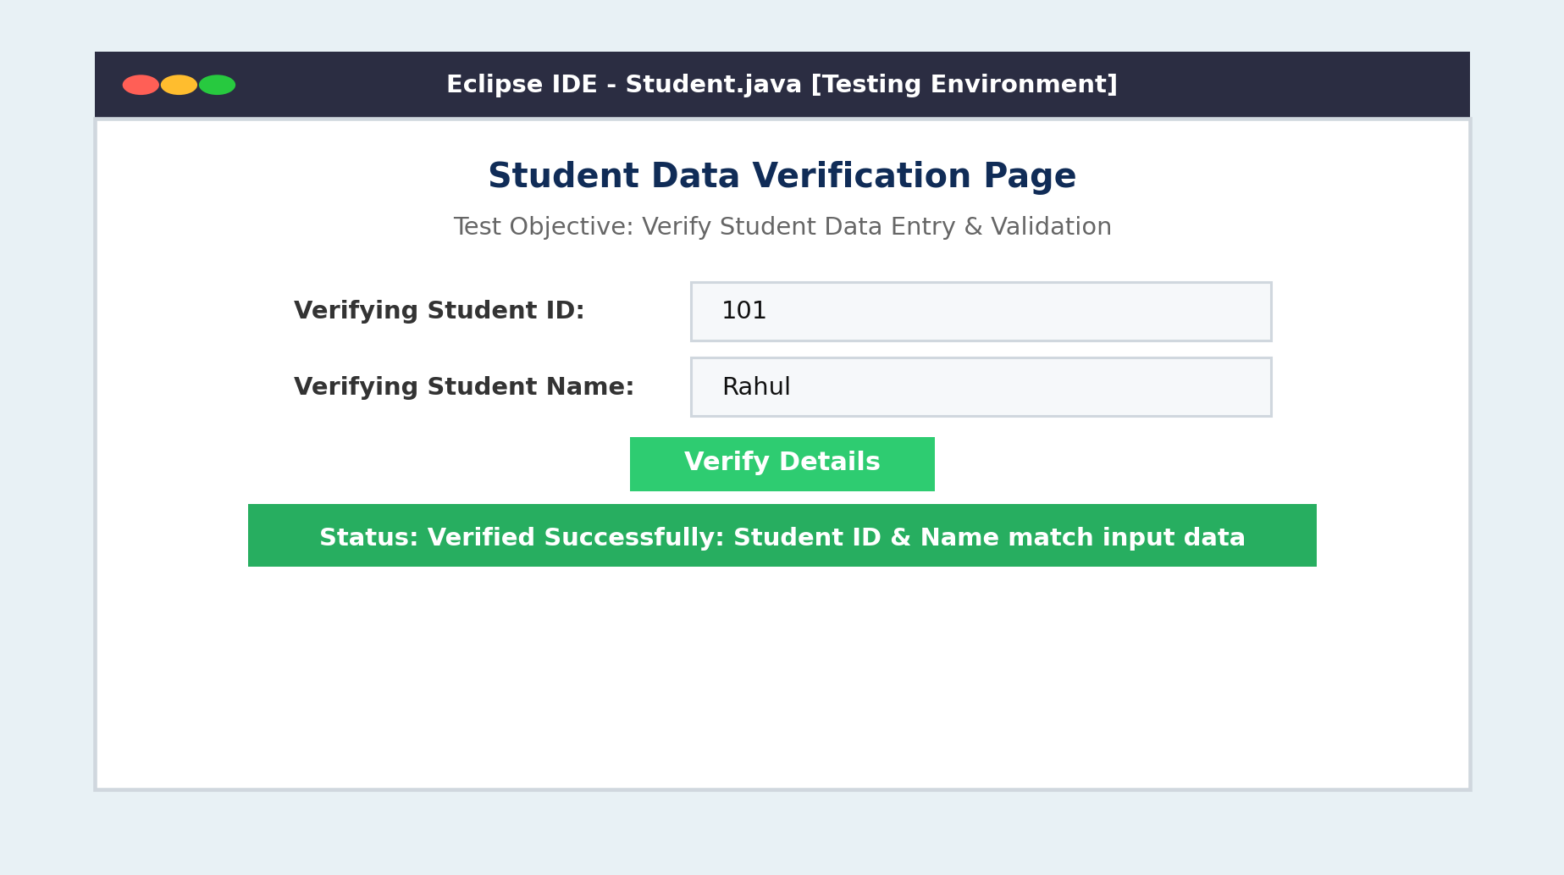
PRECONDITION: APPLICATION OPENED PAGE
Precondition verification ensuring application is opened and ready in Eclipse IDE.
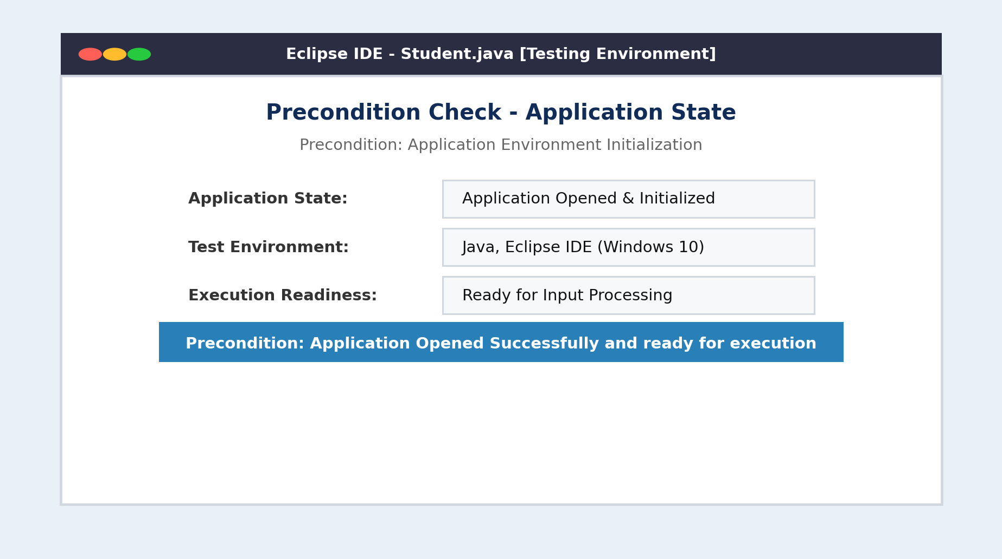
EXPECTED RESULT: STUDENT RESULT DISPLAY & STATUS
Final console output displaying student results with Status (Pass/Fail): Pass.
